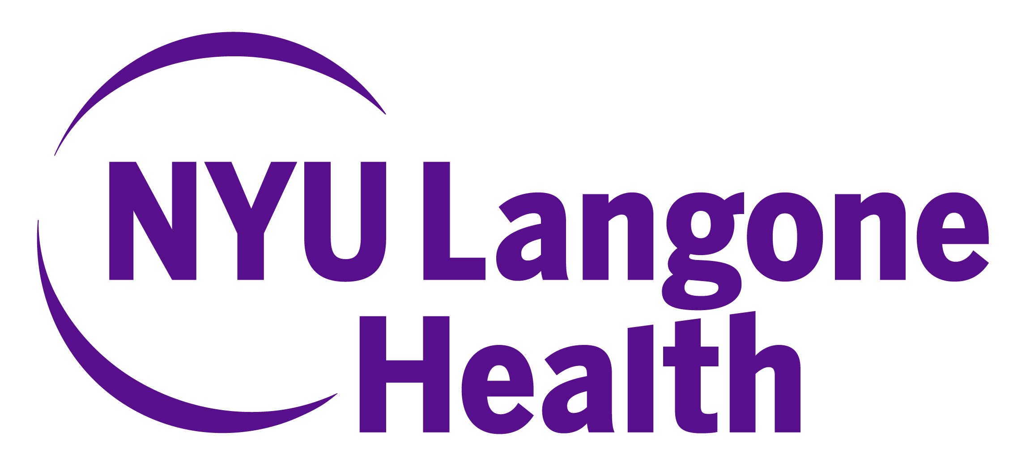
Child Abuse Pediatrician
NYU Grossman School of Medicine: Pediatrics
Description
The Department of Pediatrics at NYU Grossman School of Medicine is seeking a board certified/board eligible Child Abuse Pediatrician for a faculty position at NYU Grossman School of Medicine. We are seeking a full-time faculty member to join our department. The Division of General Pediatrics includes the Subdivision of Child Abuse Pediatrics that currently consists of two child abuse pediatricians. The child abuse pediatrician will provide inpatient and phone consultations for suspected child abuse and neglect for Bellevue Hospital and NYU Langone Health and outpatient evaluations and consultations for the Frances Loeb Child Protection and Development Center at Bellevue Hospital and the EAC-Nassau County CAC. There are opportunities to teach medical student, residents and Child abuse fellows. There are also opportunities for mentorship in research.
Salary Range $210,000-220,000
The salary range listed is for full-time employment and does not include incentive compensation or benefits. Actual salary may not fall within the listed salary range; consideration will be made for experience, training, hospital/community need, and other factors.
Qualifications
The ideal candidate will be BC/BE in Pediatrics and Child Abuse pediatrics with strong clinical skills and a commitment to academic excellence. Applicants are eligible for a faculty appointment at NYU Grossman School of Medicine, Department of Pediatrics. NYU Langone Health offers competitive salary and benefits and is an equal opportunity employer.
Application Instructions
Interested individuals are invited to submit a letter of interest and curriculum vitae electronically through Interfolio. If you have any questions please reach out to Mr. Kevin Scott at kevin.scott@nyulangone.org. Cover letters should be addressed to Dr. Lori Legano Director of Child Protection Services for the Department of Pediatrics. Please apply via this link: https://apply.interfolio.com/176124

